**Worksheet – 2.1**

**Student Name:** Vivek Kumar  **UID:** 21BCS8129

**Branch:** BE-CSE (LEET) **Section/Group:** 809/A

**Semester:** 4th **Date of Performance:** 28/03/2022

**Subject Name:** Programming in Python Lab  **Subject Code:** 20CSP-259

**1. Aim/Overview of the practical:**

1. Python program to check whether the string is Symmetrical or Palindrome.
2. Python program to find uncommon words from two Strings.
3. Write a Python program to add 'ing' at the end of a given string (length should be at least 3). If the given string already ends with 'ing' then add 'ly' instead. If the string length of the given string is less than 3, leave it unchanged. Example:- Sample String : 'abc' Expected Result : 'abcing' Sample String : 'string' Expected Result : 'stringly'

**2. Task to be done/ Which logistics used:**

1. Check whether the string is Symmetrical or Palindrome.
2. Find uncommon words from two Strings.
3. Add 'ing' at the end of a given string (length should be at least 3). If the given string already ends with 'ing' then add 'ly' instead. If the string length of the given string is less than 3, leave it unchanged.

**3. Steps for experiment/practical/Code:**

1. Check whether the string is Symmetrical or Palindrome.

**Sourse Code:**

*# Symmetrical Function*

def symm(string):

l = len(string)

flag = 0

if l%2 == 0:

mid = l//2

else:

mid = l//2 + 1

s1 = 0

s2 = mid

while(s1 < mid and s2 < l):

if (string[s1] == string[s2]):

s1 = s1 + 1

s2 = s2 + 1

else:

flag = 1

break

if flag == 0:

print("The entered string {} is symmetrical".format(string))

else:

print("The entered string {} is not symmetrical".format(string))

*# Palindrome Function*

def palin(string):

st = 0

end = len(string)-1

f = 0

while(st<end):

if (string[st]== string[end]):

st += 1

end -= 1

else:

f = 1

break

if f == 0:

print("The entered string {} is palindrome".format(string))

else:

print("The entered string {} is not palindrome".format(string))

*# Main code*

string = input("Enter the string: ")

palin(string)

symm(string)

1. Find uncommon words from two Strings.

**Sourse Code:**

*# Iterative method*

def iterate_uncommon(s1,s2):

list_s1 = s1.split()

list_s2 = s2.split()

uc_words = ""

for i in list_s1:

if i not in list_s2:

uc_words = uc_words+" "+i

for j in list_s2:

if j not in list_s1:

uc_words = uc_words+" "+j

return uc_words

s1=str(input('Enter 1st String: '))

s2=str(input('Enter 2nd String: '))

*# Print required answer*

print(iterate_uncommon(s1,s2))

1. Add 'ing' at the end of a given string (length should be at least 3). If the given string already ends with 'ing' then add 'ly' instead. If the string length of the given string is less than 3, leave it unchanged.

**Sourse Code:**

def inglify(string):

if len(string) < 3:

return string

elif string.endswith('ing'):

return string + 'ly'

else:

return string + 'ing'

string = input("Enter The String: ")

print(inglify(string))

**4. Result/Output/Writing Summary:**

1. Find area of Circle using different types of method.

**Output:**

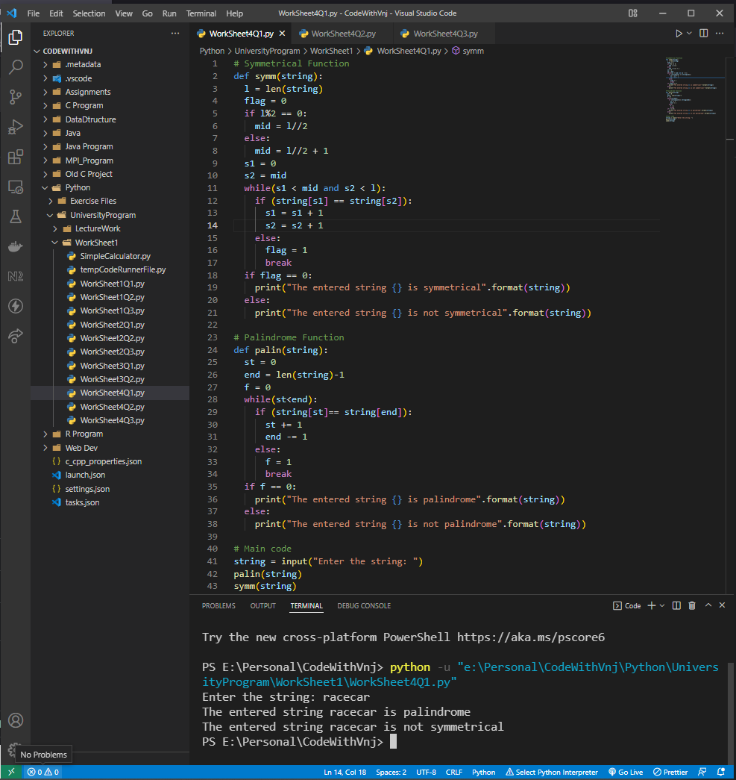

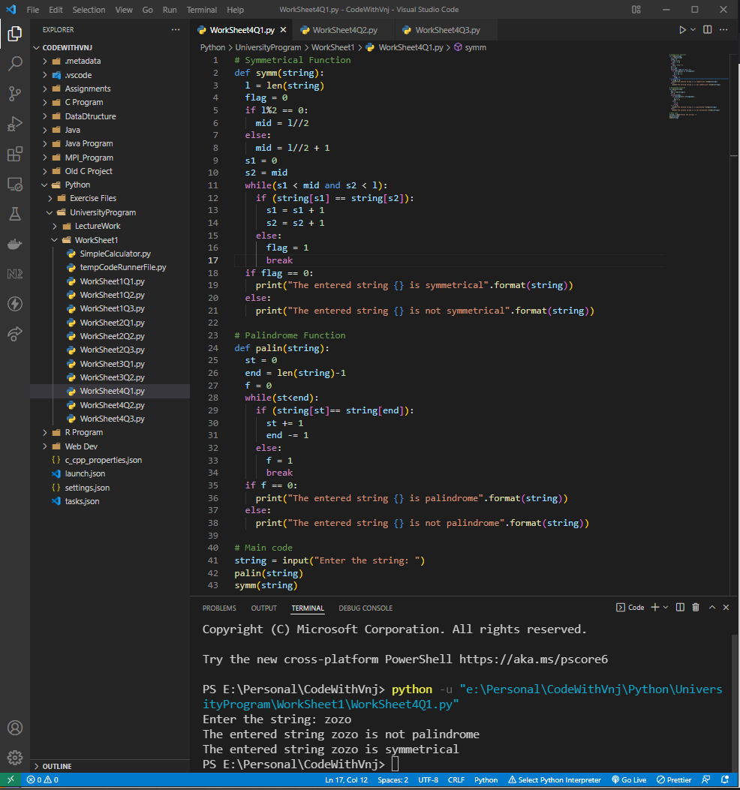

1. Find uncommon words from two Strings.

**Output:**

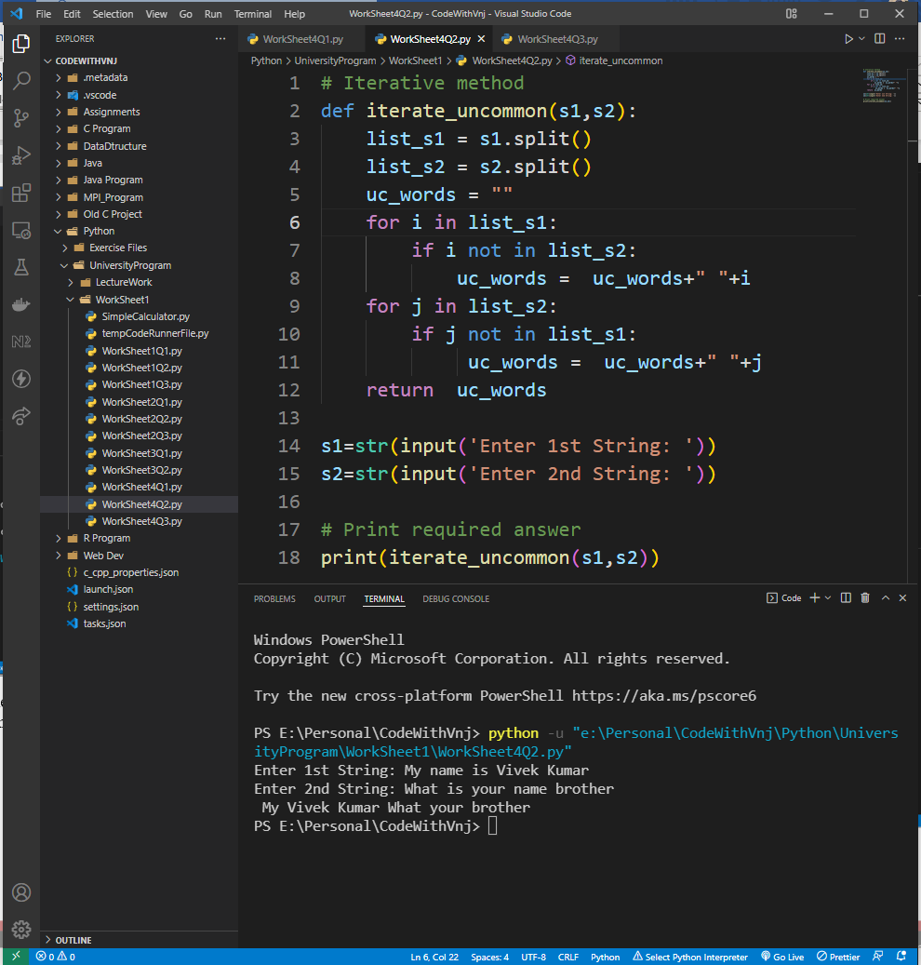

1. Add 'ing' at the end of a given string (length should be at least 3). If the given string already ends with 'ing' then add 'ly' instead. If the string length of the given string is less than 3, leave it unchanged.

**Output:**

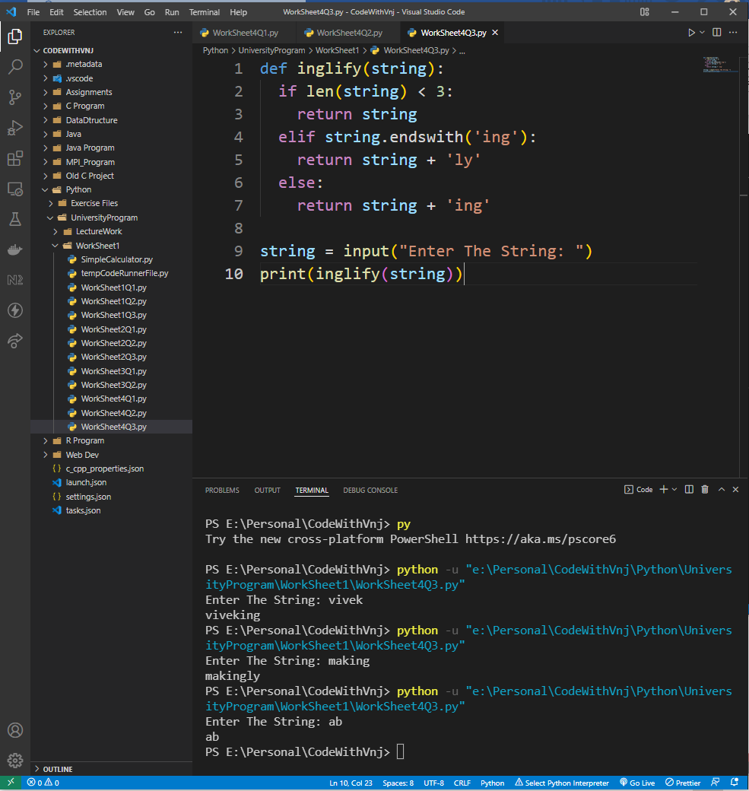

**Learning outcomes (What I have learnt):**

**1.** I have learnt, String Manipulation.

**2.** Learnt to find the Symmetrical & Palindrome String.

**3.** Learnt to compare the two sentences with each words.

**Evaluation Grid (To be created as per the SOP and Assessment guidelines by the faculty):**

|  |  |  |  |
| --- | --- | --- | --- |
| Sr. No. | Parameters | Marks Obtained | Maximum Marks |
| 1. |  |  |  |
| 2. |  |  |  |
| 3. |  |  |  |
| 4 |  |  |  |